Assigment-1

**Part 3:**

Answer the following questions.

What is GitHub?

* It is a web-based open-source repository hosting service using Git. It provides access control and several collaboration feature such as bug tracking, feature requests, task management for every project.

When was it created?

* Github was created on Feb 8, 2008.

Why? By who?

* Github was created by Tom Preston-Werner, Chris Wanstrath, P. J. Hyett, Scott Chacon.

What similar platforms exist?

* Other similar platforms are GitLab, Beanstalk, SourceForge, Launchpad, Gitea, Gogs.

Why would you use such a platform?

* Such platforms allows the code to be reviewed by the community.
* The coder can collaborate and track changes in the code across different versions.
* As platforms like GitHub are a repository, it allows the users work to be reachable to the public.

**Part :4 (Tutorial Screen shots.)**

Level 1 code (To Commit): -

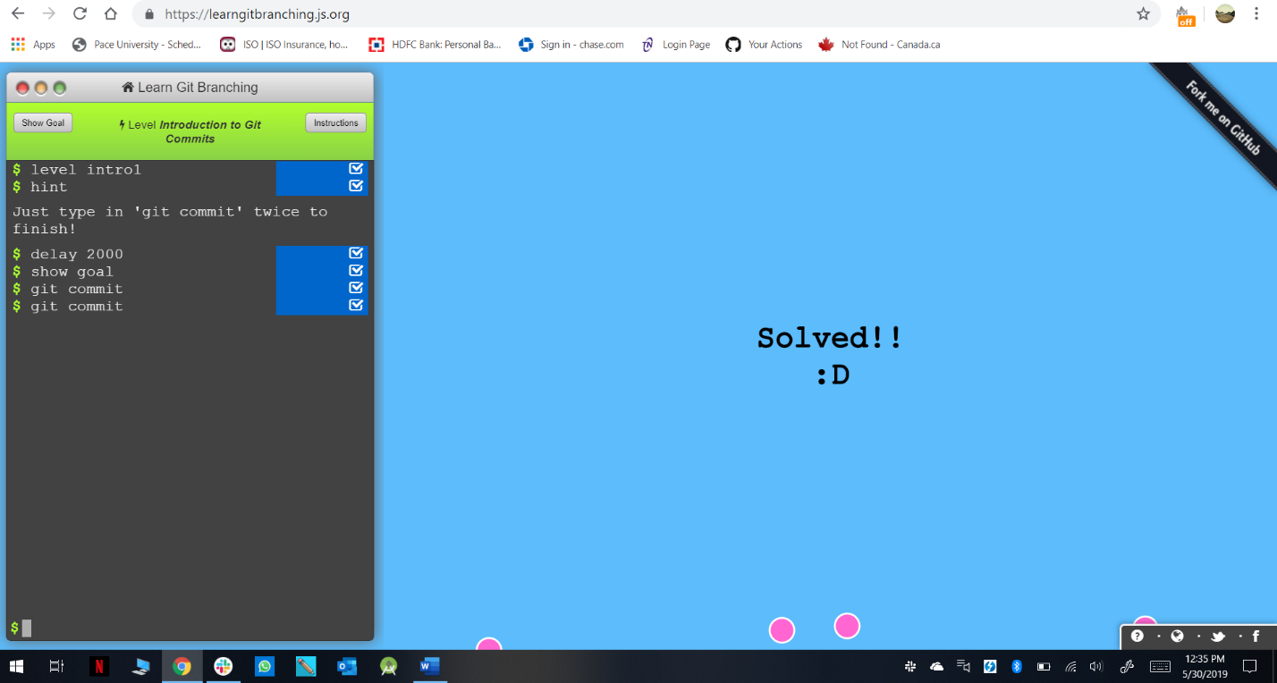

Level 2 code (Branching): -

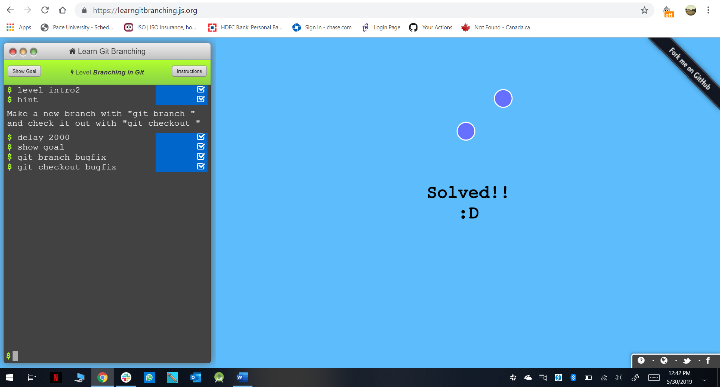

Level 3 code (Merging in Git): -

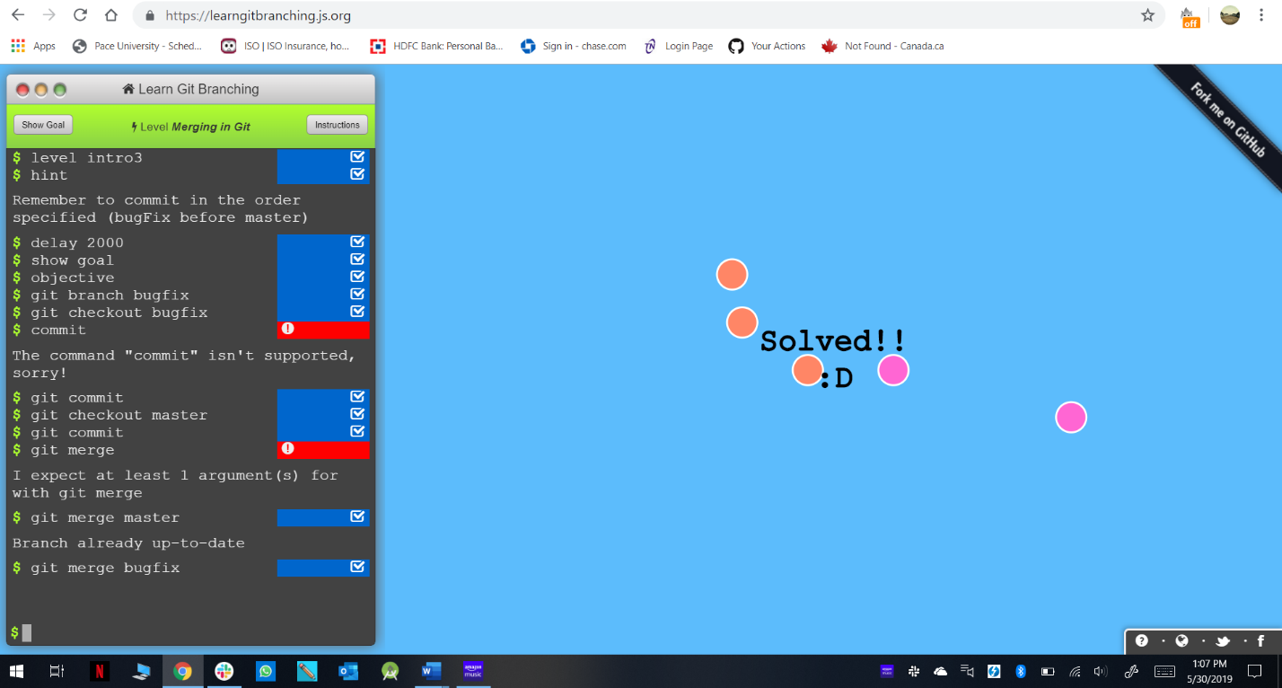

Level 4(Rebase Introduction): -

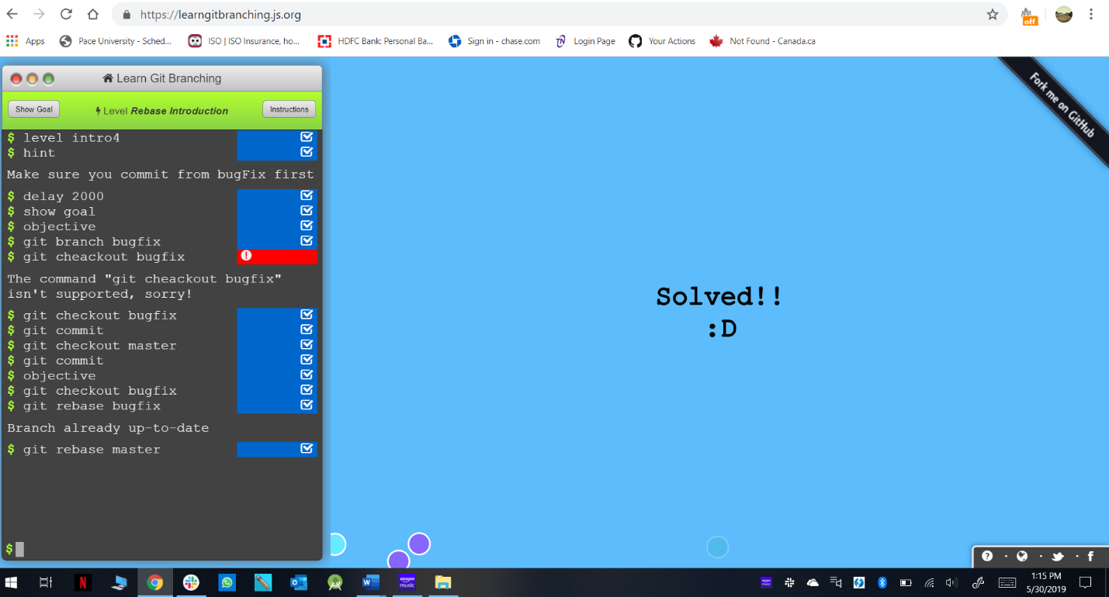

Level 5(Moving Around): -

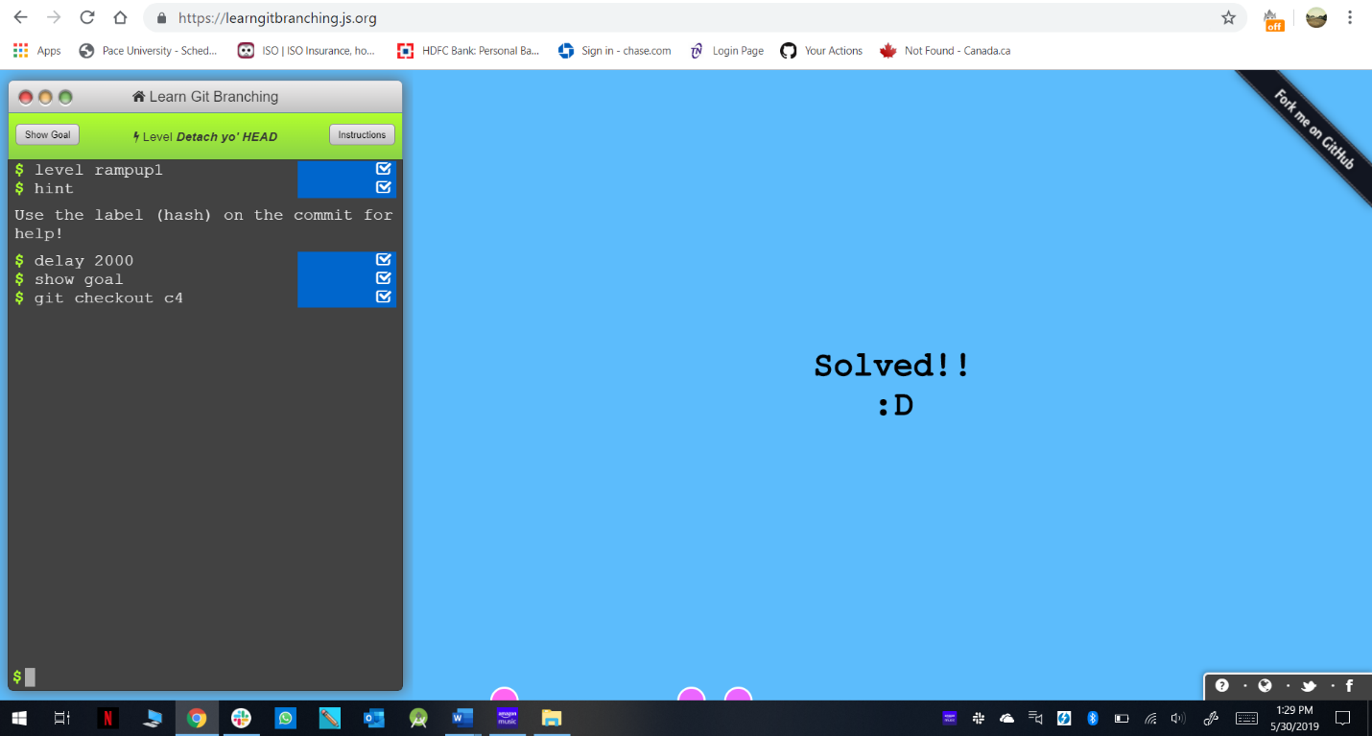

Level 6(Relative Reference): -

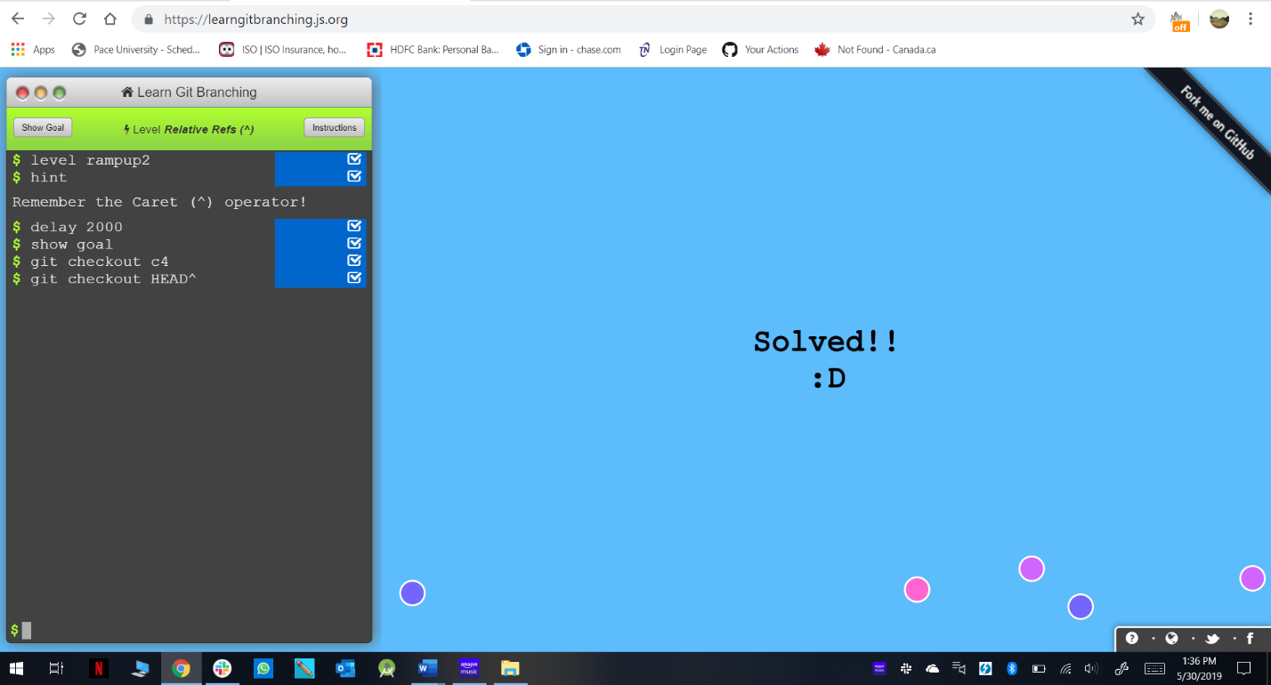

Level 7(Relative Reference-2): -

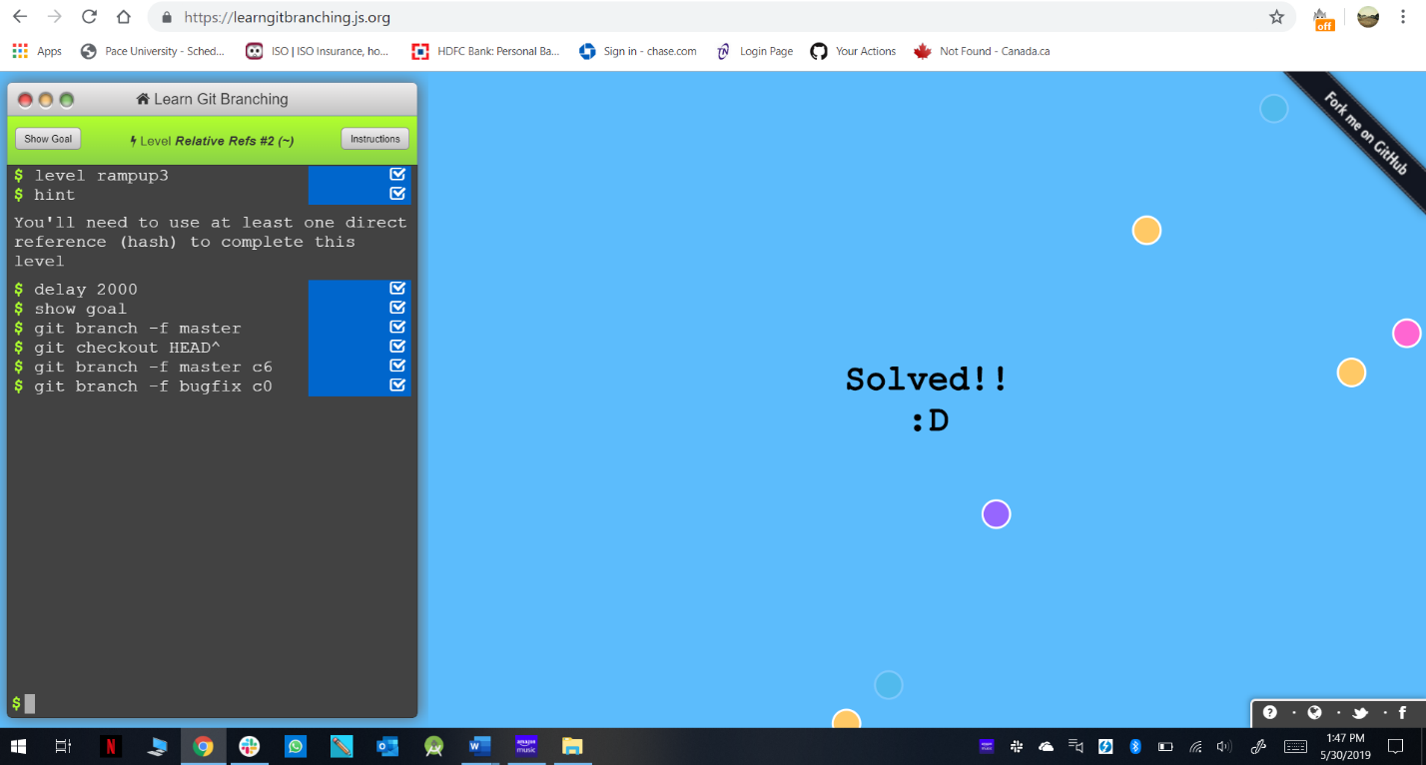

Level 8(Reversing Changes in Git): -

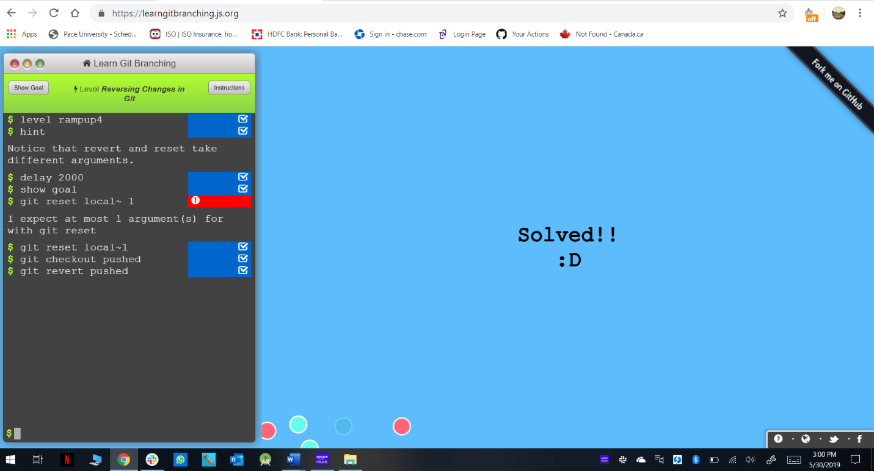

Level 9(Cherry-pick Intro): -

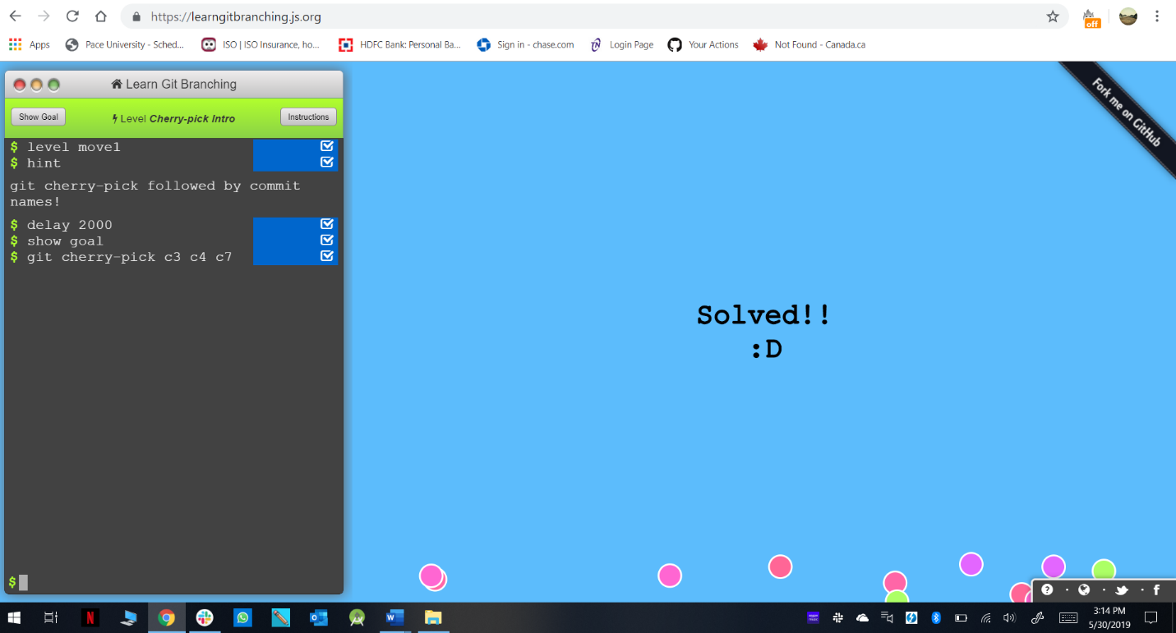

Level 10(Interactive Rebase Intro): -

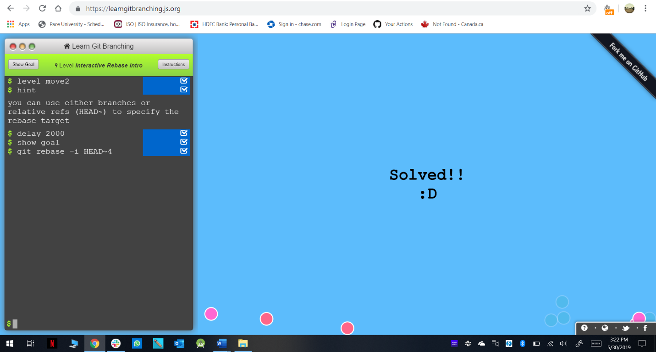

Level 11(Grabbing Just 1 Commit): -

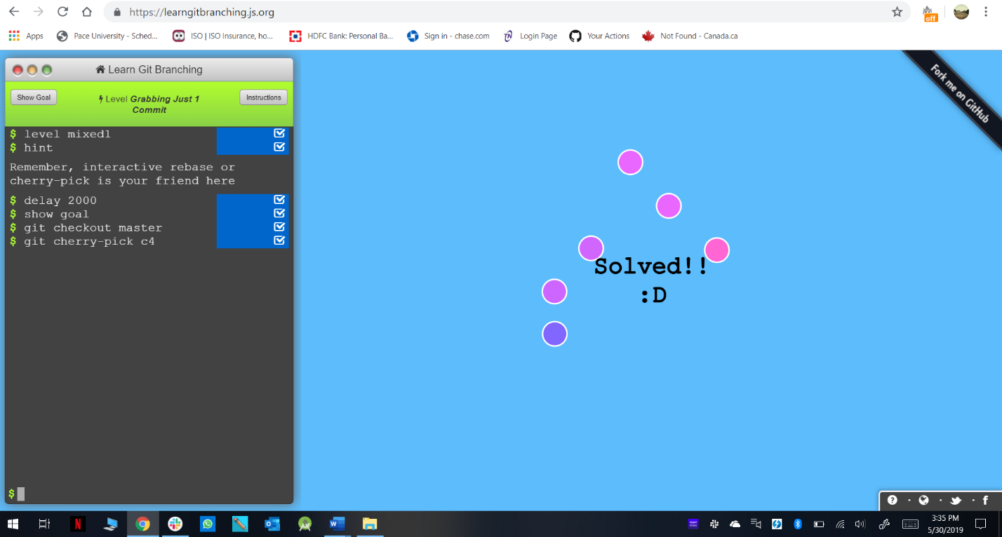

Level 12(Juggling Commits): -

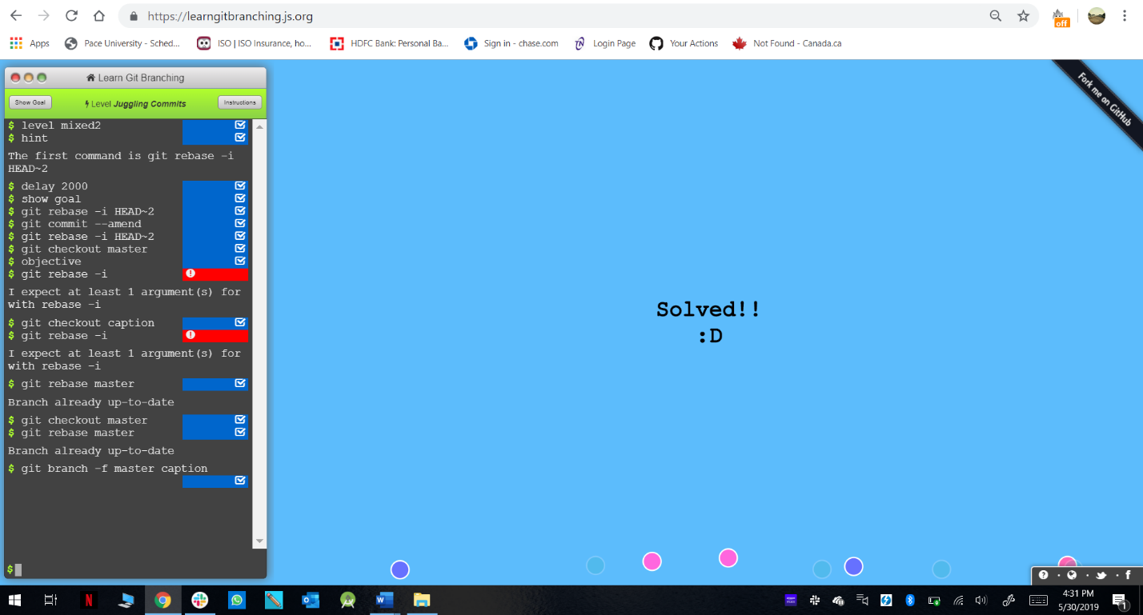

Level 13(Juggling Commits-2): -

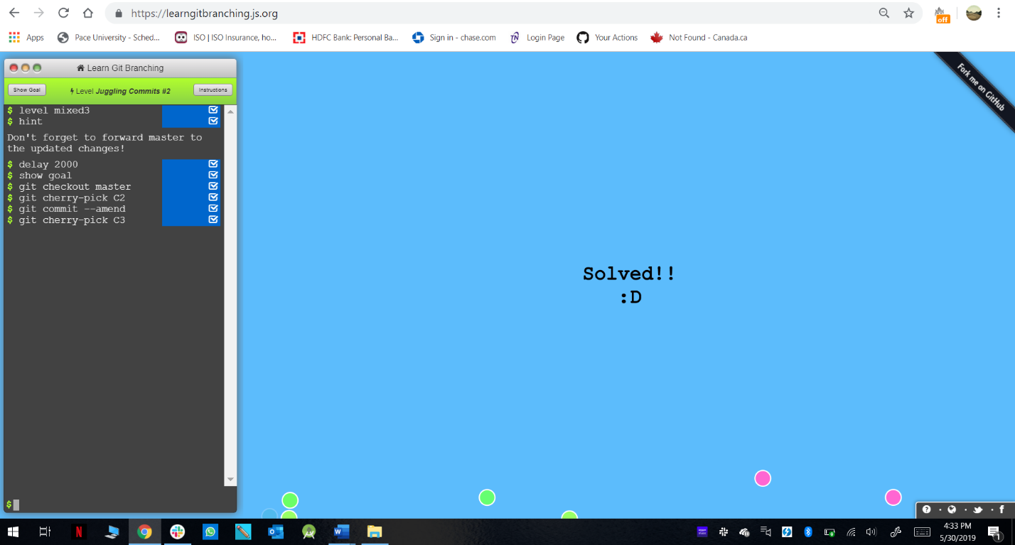

Level 14(Git Tags): -

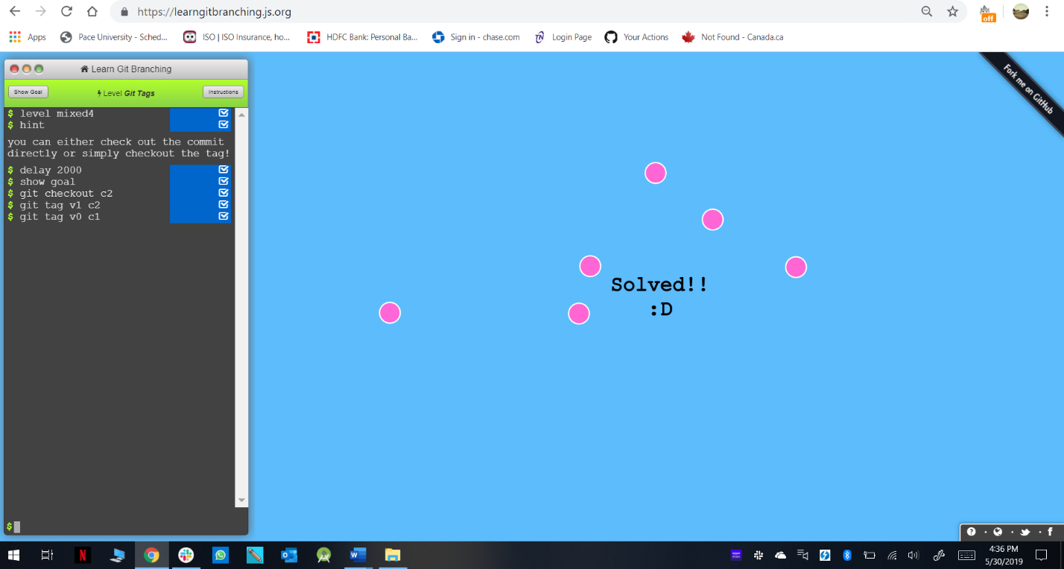

Level 15(Git Describe): -

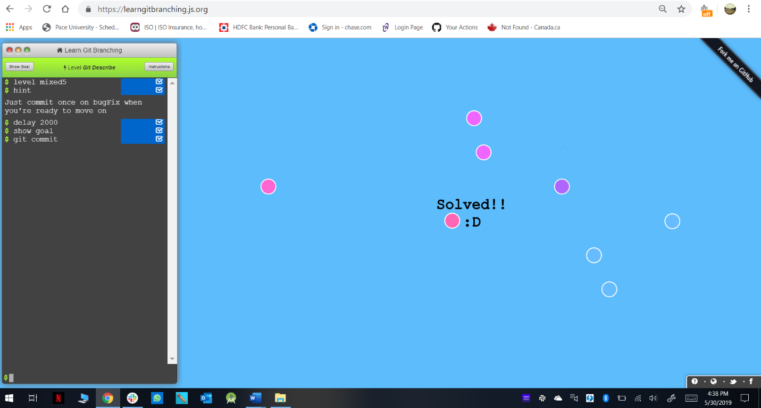

Level 16(Rebasing over 9000 times): -

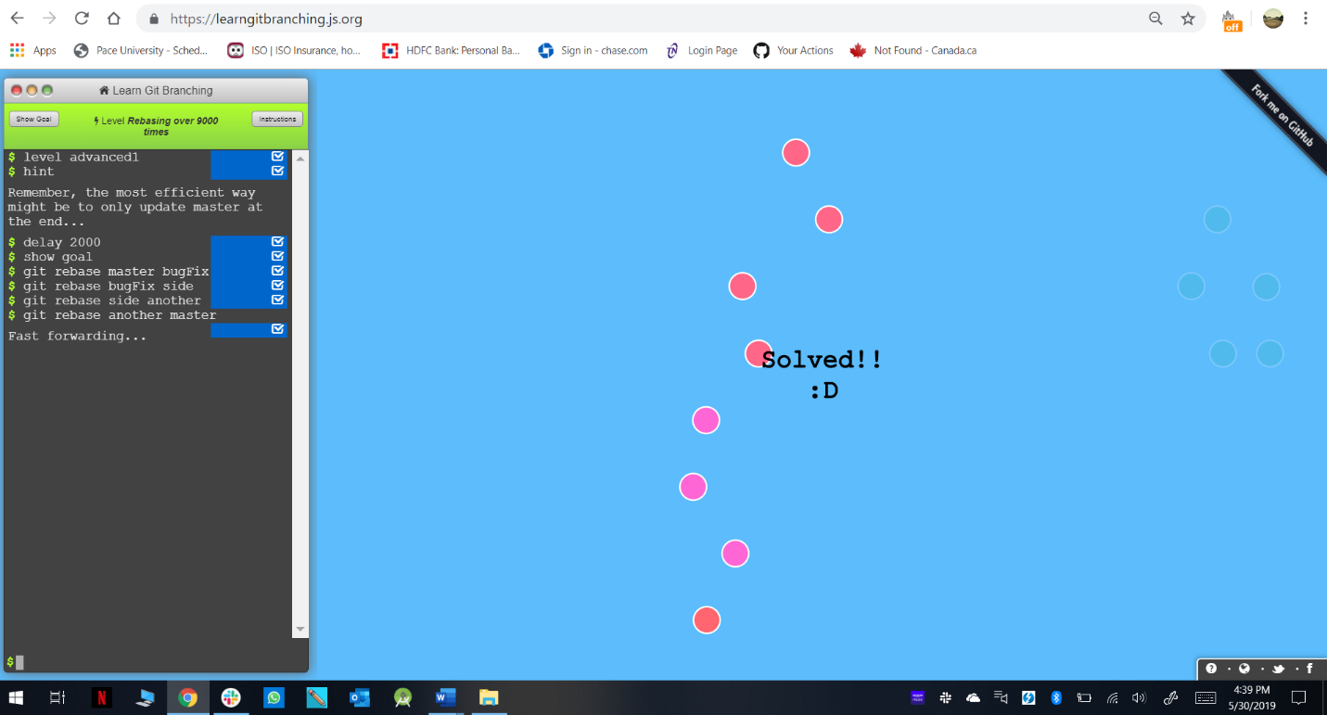

Level 17(Multiple Parents): -

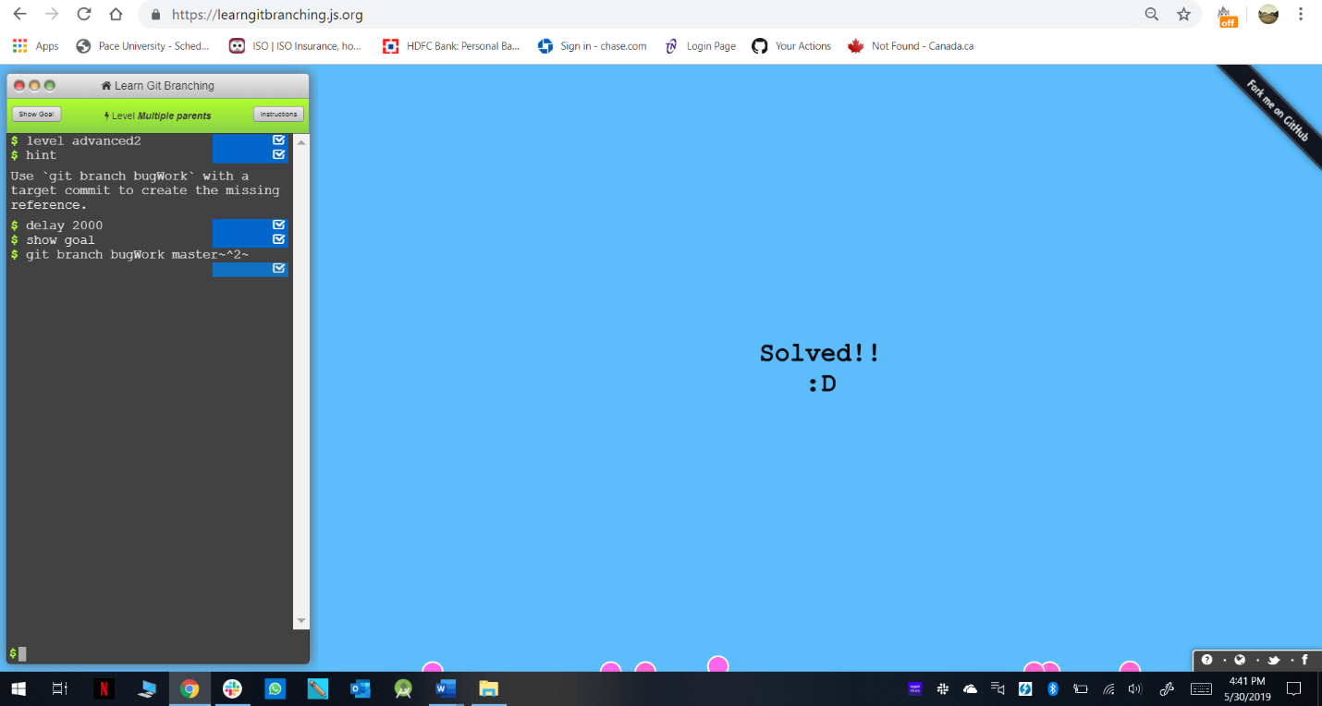

Level 18(Branch Spaghetti): -

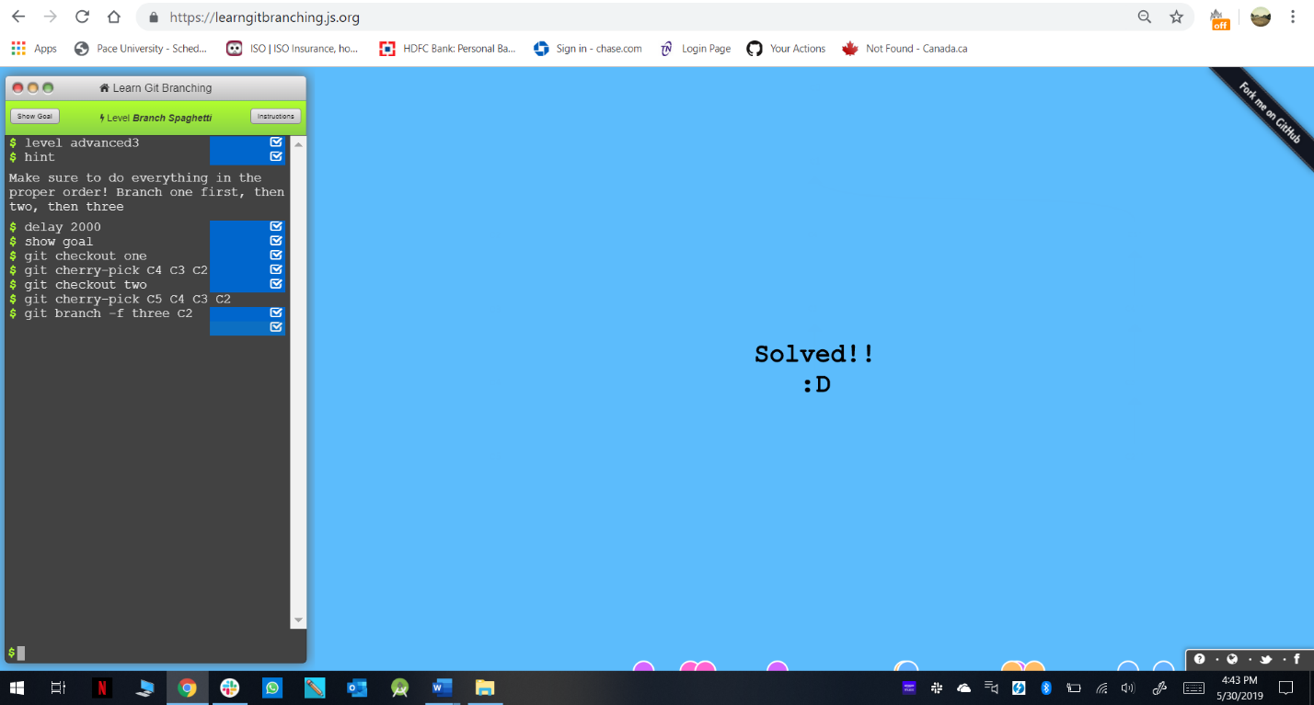

Final List: -

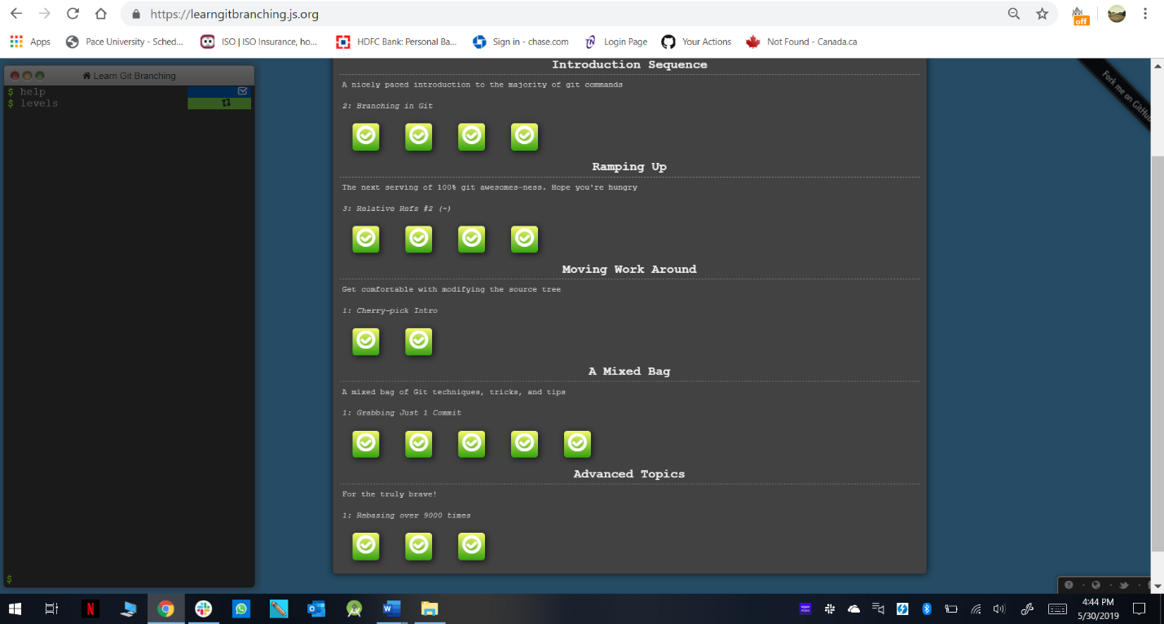

**REMOTE: -**

Level 1(Clone Intro): -

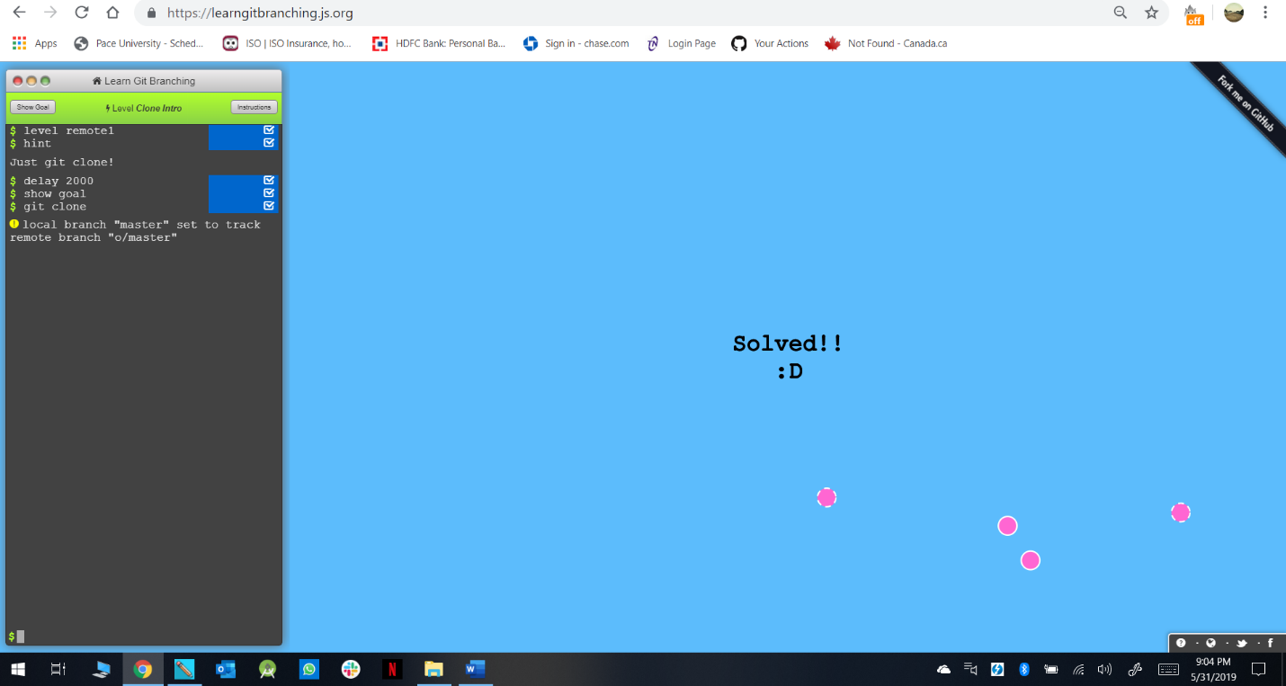

Level 2(Remote Branches): -

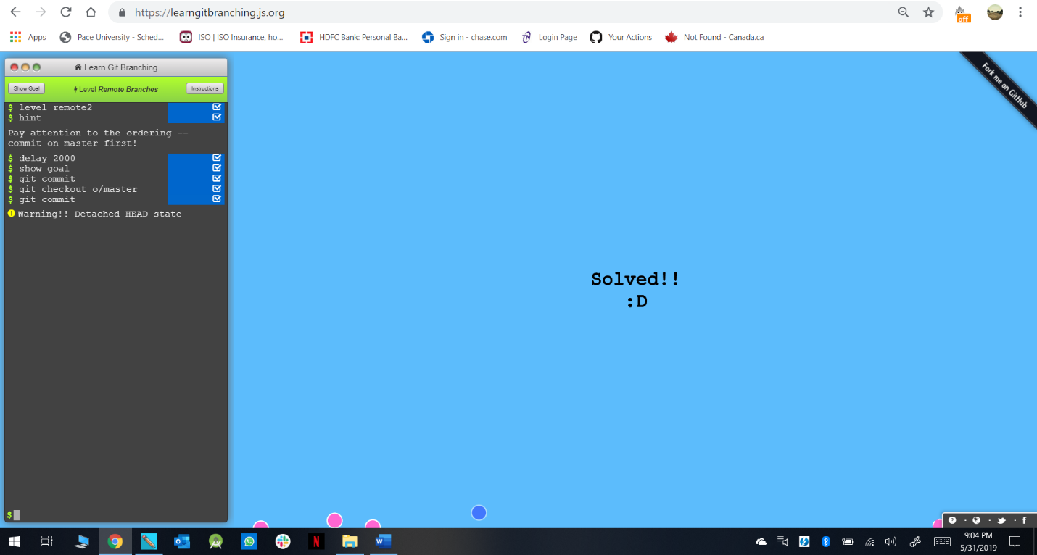

Level 3(Git Fetching): -

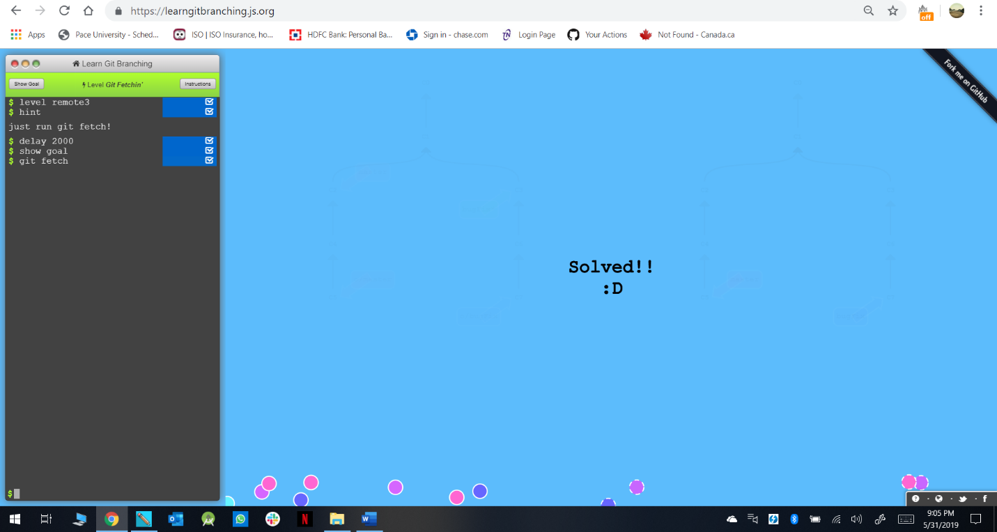

Level 4(Git Pulling): -

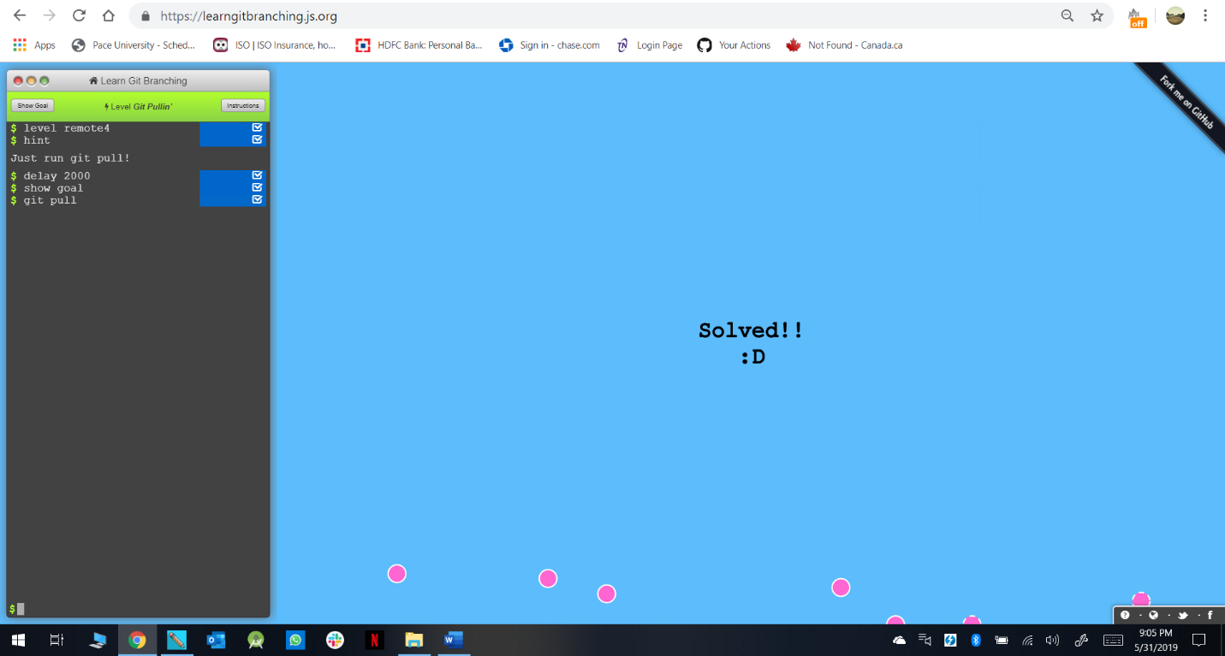

Level 5(Faking Teamwork): -

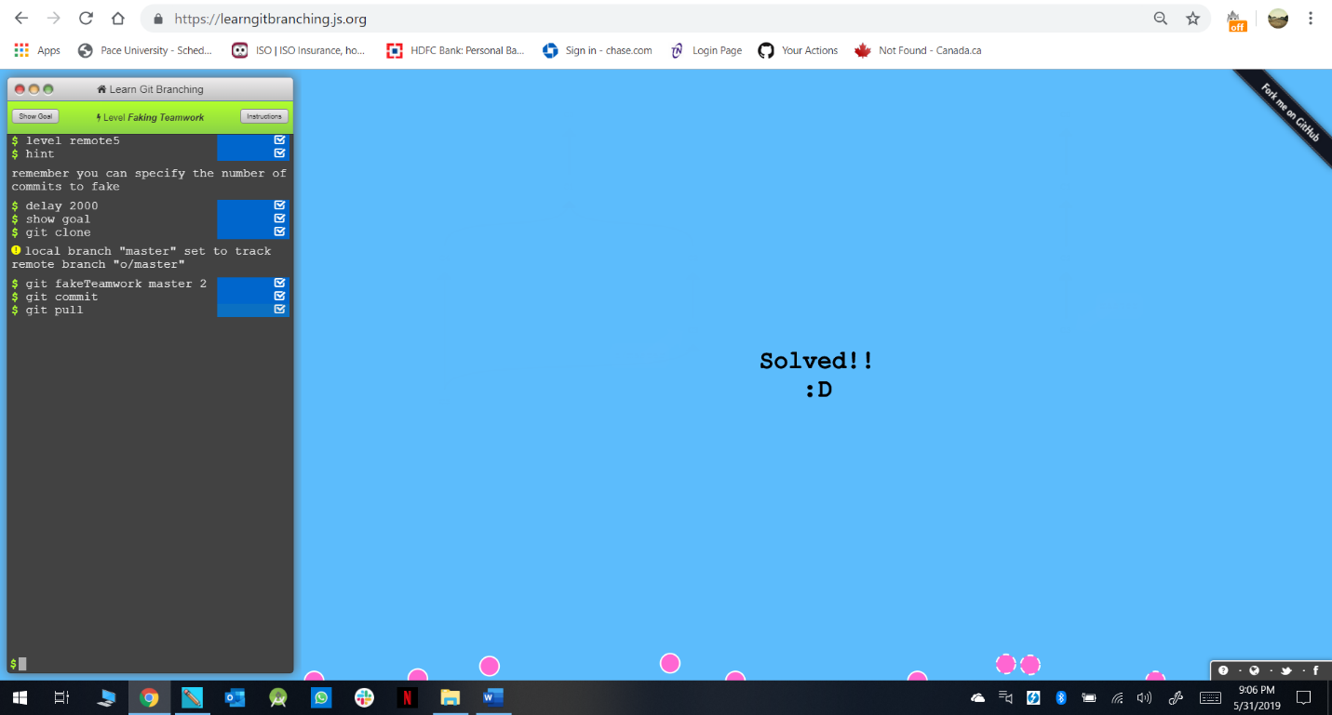

Level 6(Git Pushing): -

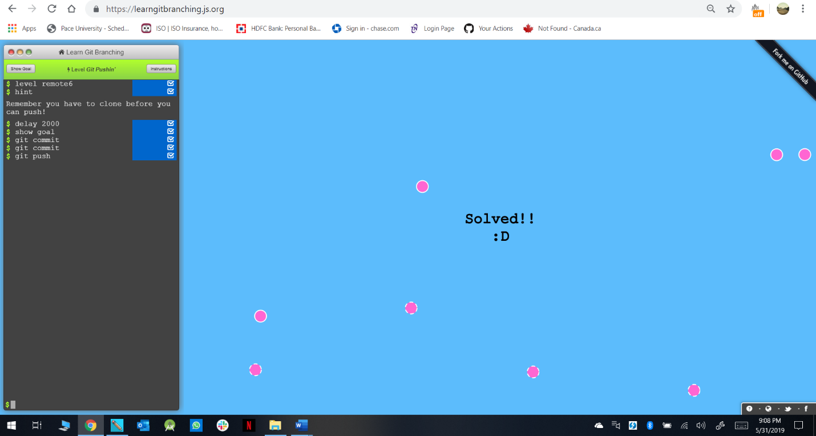

Level 7(Diverged History): -

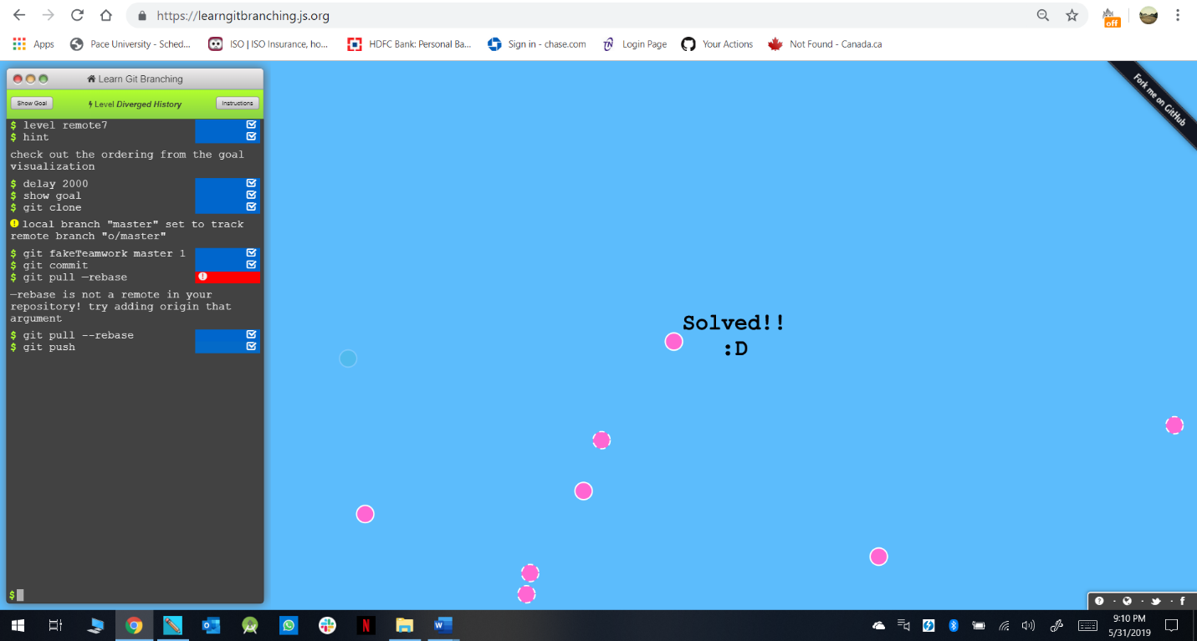

Level 8(Push Master): -

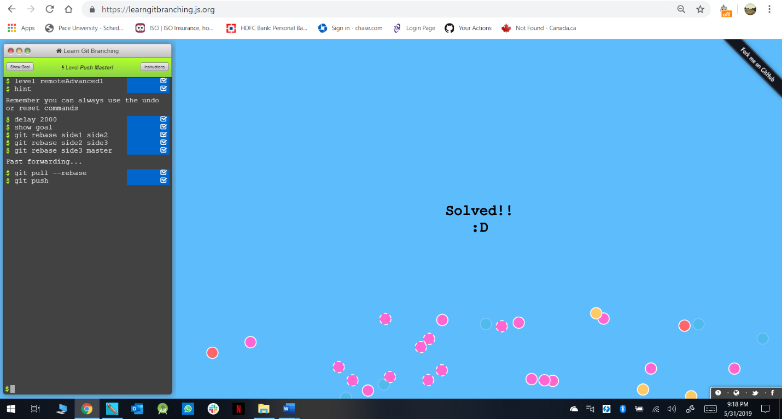

Level 9(Merging with Remotes): -

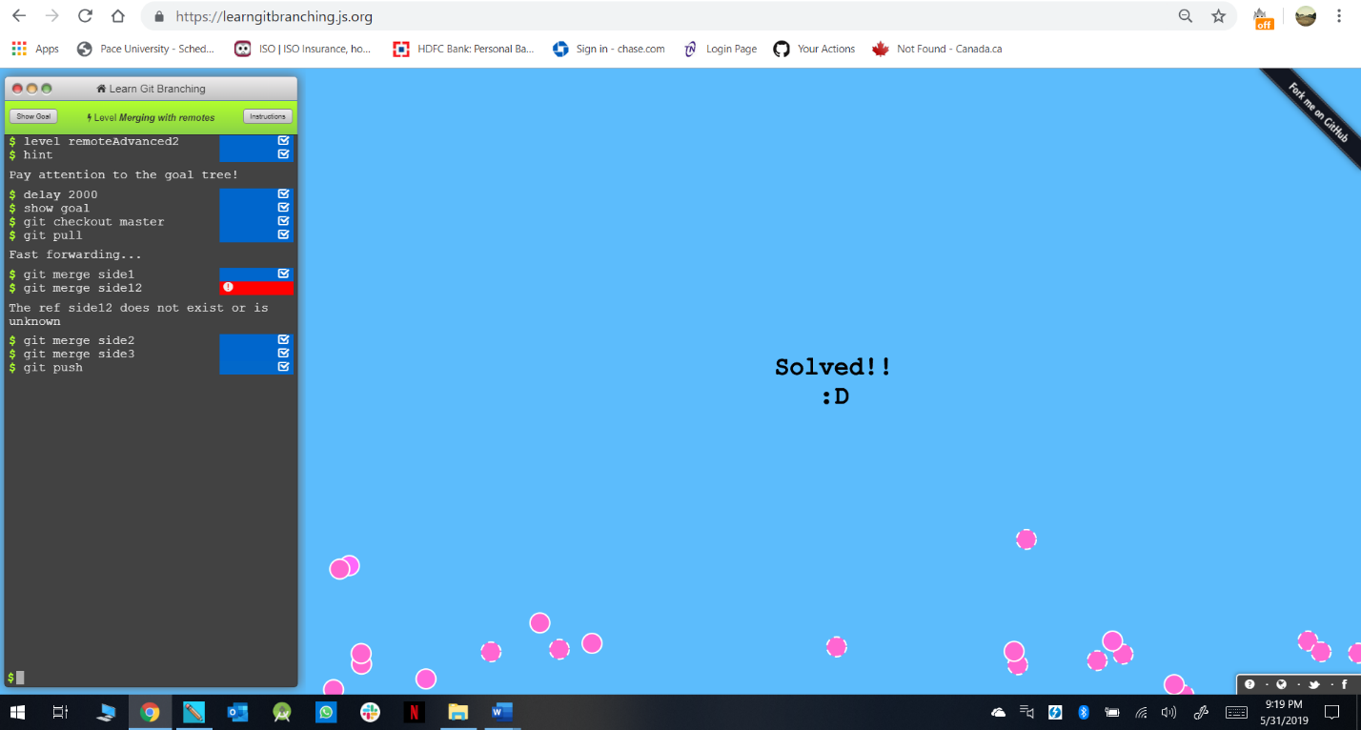

Level 10(Remote Tracking): -

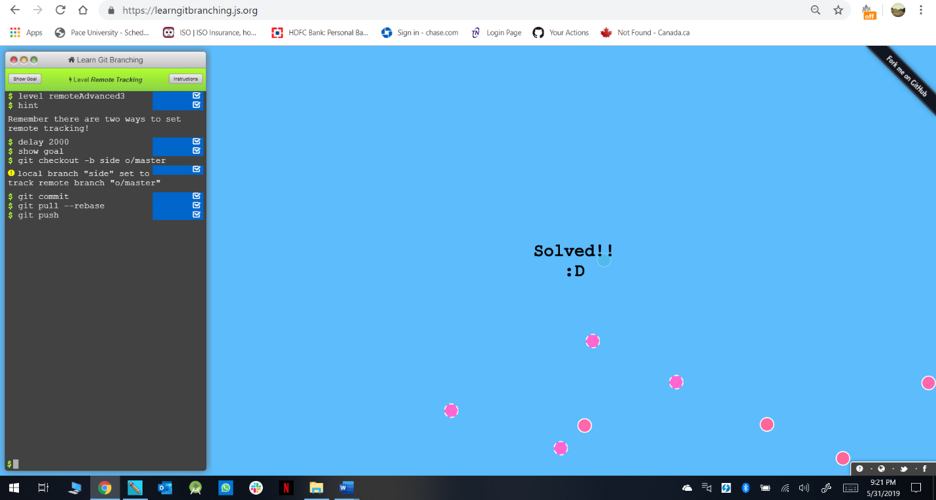

Level 11(Git Push Arguments): -

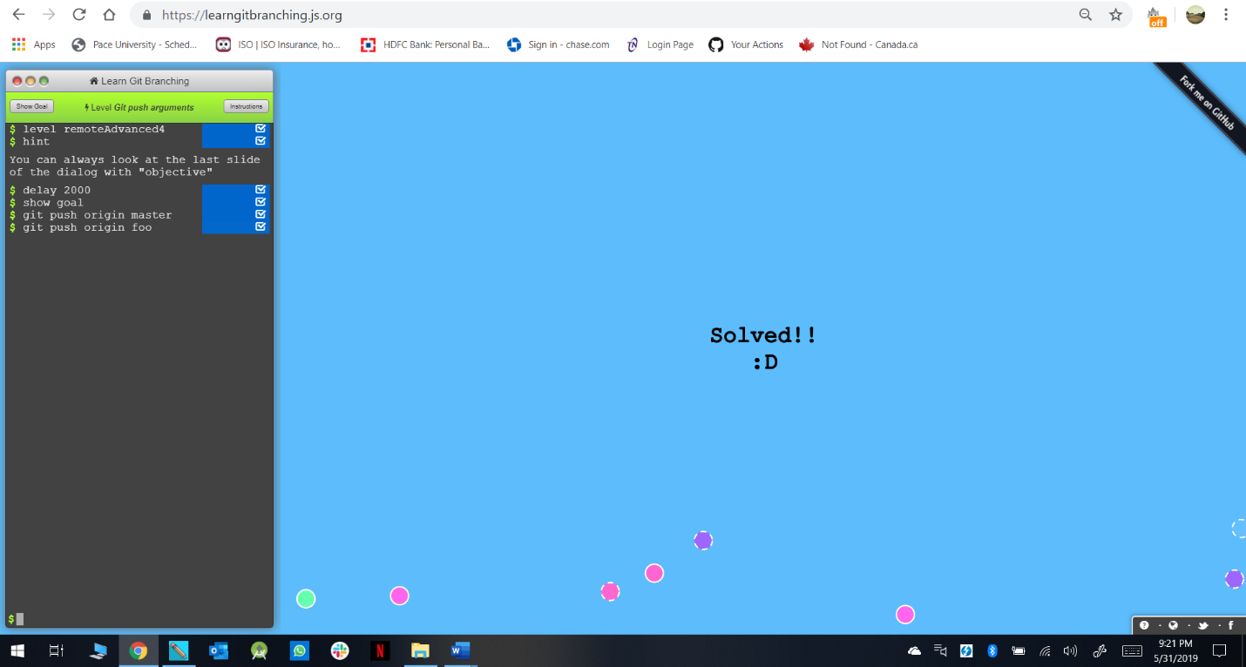

Level 12(Git Push Arguments-2): -

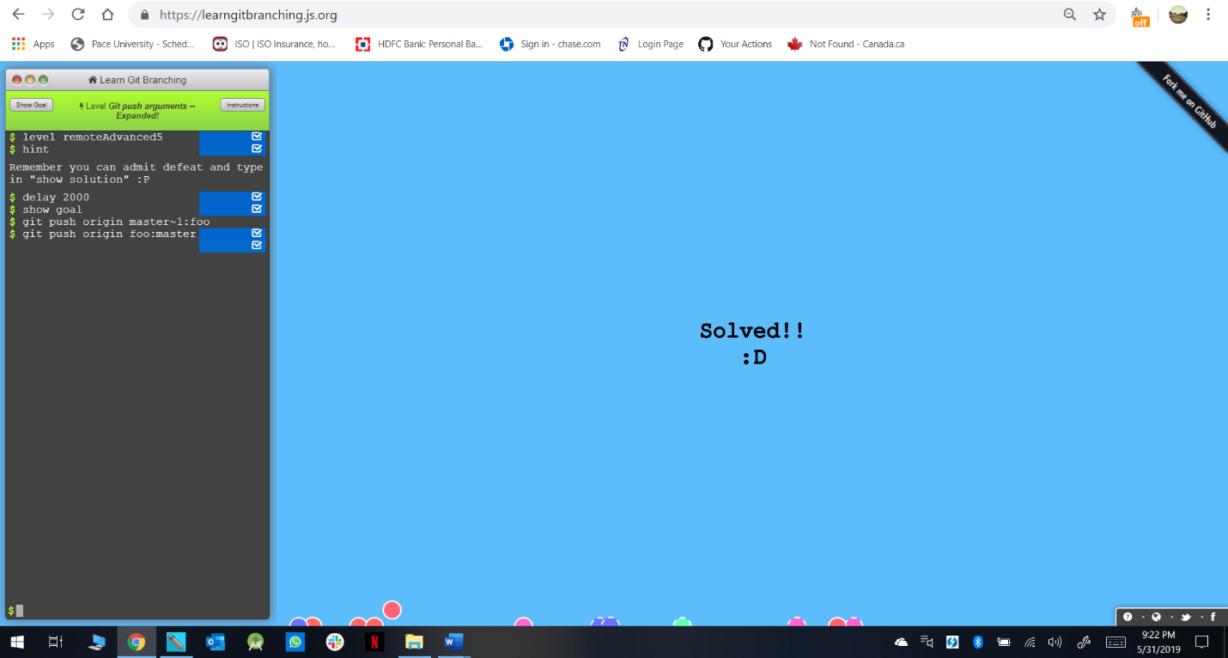

Level 13(Fetch Arguments): -

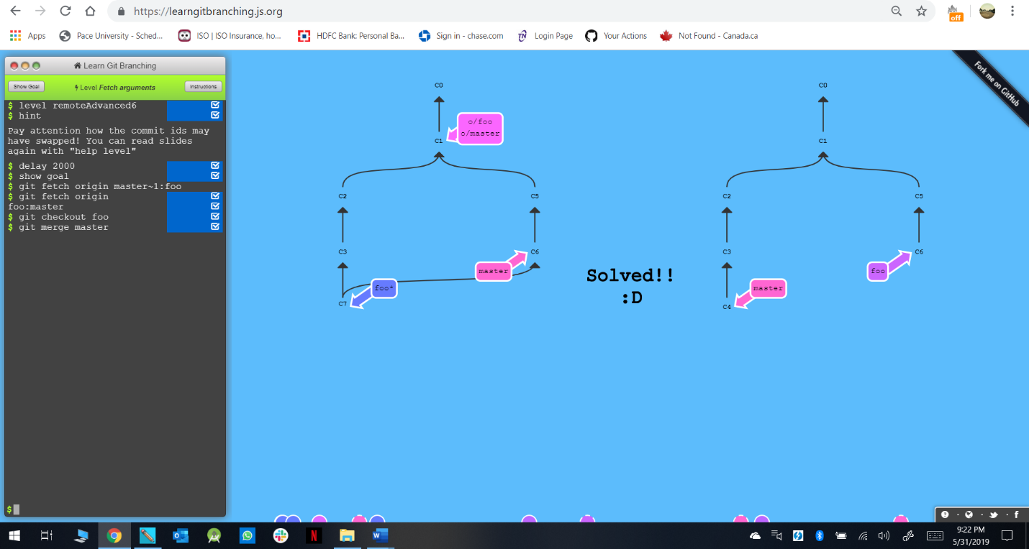

Level 14(Source of Nothing): -

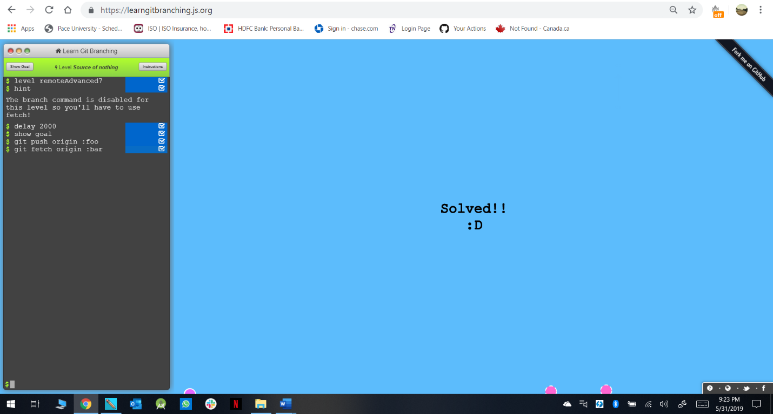

Level 15(Pull Arguments): -

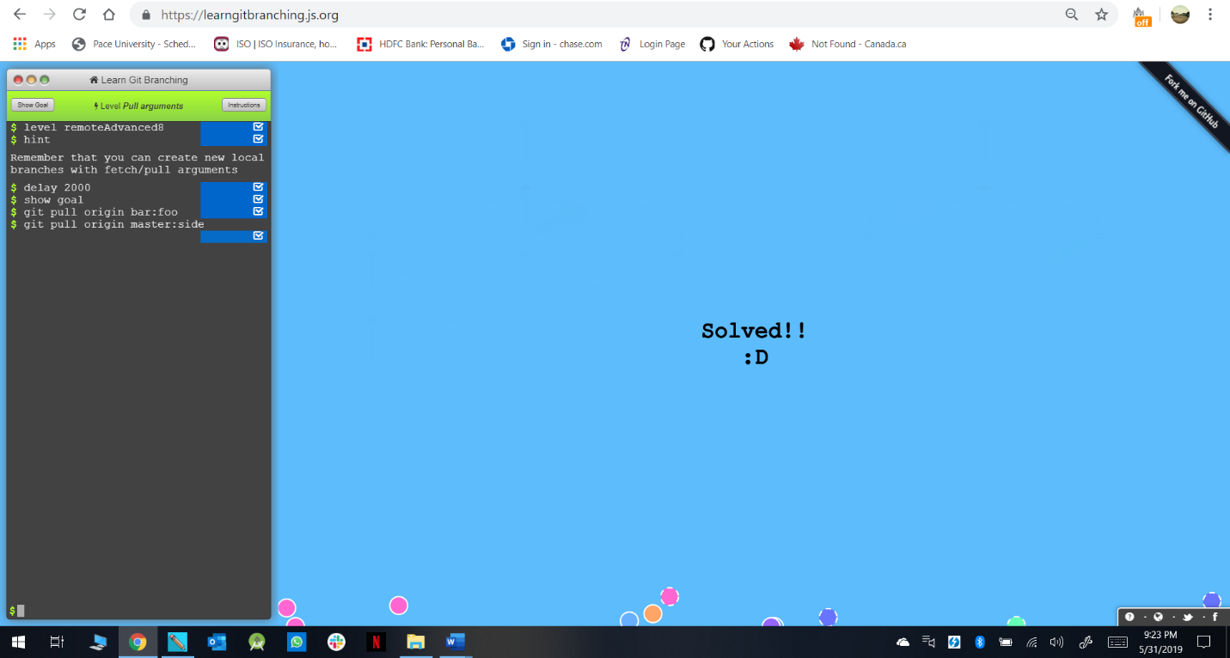

Complete: -

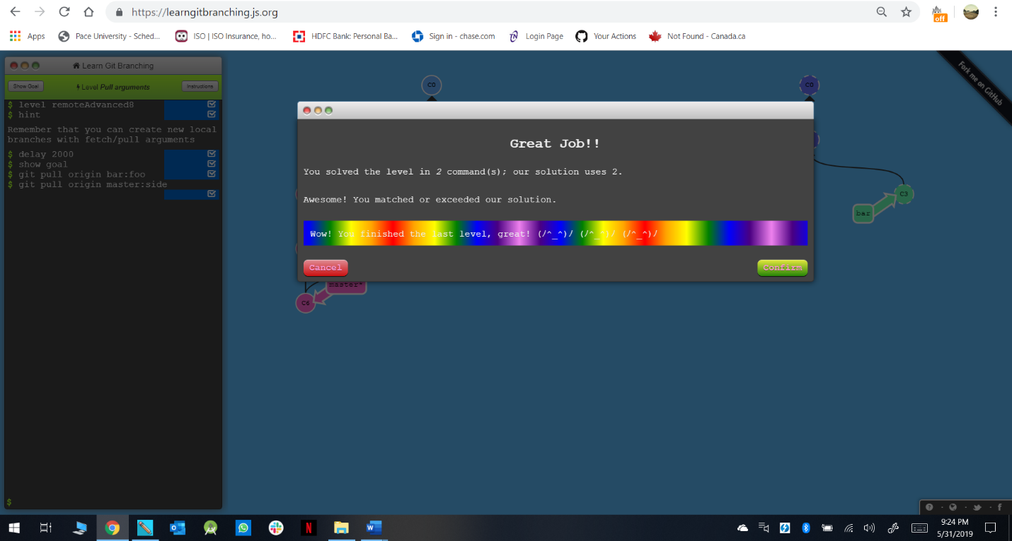

**Part 5:**

Define the following terms in the context of Git (2 lines maximum):

* Repository: - A directory or storage space where projects can live. It can be a folder on computer, or it can be a storage space on GitHub or another online host. Files such as code files, text files, image files, etc. can be stored in repository.
* Commit: - This is the command that gives Git the power. When you Commit, you are taking a snapshot of repository at that point in time, giving a checkpoint to which, you can reevaluate or restore projects to any previous date.
* Push: - Pushing refers to sending your committed changes to a remote repository, such as repository hosted on GitHub. For e.g. if you change something locally, you want to then “push” those changes so that others can access them.
* Branch: - The Branch command lets the user to build timeline of commits, of changes and file additions. It allows working with multiple collaborators.
* Fork: - A fork is a copy of a repository. Forking a repository allows you to freely experiment with changes without affecting the original project.
* Merge: - When you’re done working on a branch, you can merge your changes back to the master branch, which is visible to all collaborators.
* Clone: - Cloning a git repository means that you create a local copy of the code provided by developer. Cloning a repository means that you are downloading a copy of the source code from the source control.
* Pull: - If you are working on a local computer and want the most up-to-date version of your repository to work with, “pull” changes down from GitHub with command git pull.
* Pull request: - Pull request lets you tell others about the changes you have pushed to a branch in a repository on GitHub.

**Part 7:**

* *Strategy used to update the README.md: -*

1. Open GitHub URL that is given in the browser.
2. Open the README.md file
3. Fork the repository to edit the file and insert the Name, Date and Time.
4. Commit the changes.
5. Create a PULL request for the forked repository so the it is merged with the master branch.

* *Commands to upload the word file: -*

1. Create the word file GajjarAdityaTutorial-05-29-2019.
2. Create a repository in GitHub account by the name CS6392019.
3. Using “git clone address” Clone the repository with the file.
4. Using “git status” check the status.
5. Using “git add” add the file to the repository.
6. Using “git commit -m (message)” commit the file to be ready so that it can be pushed to the repository.
7. Using “git push” push the file into the repository.